
CLEAR REFLECTION

MIRROR CATEGORY
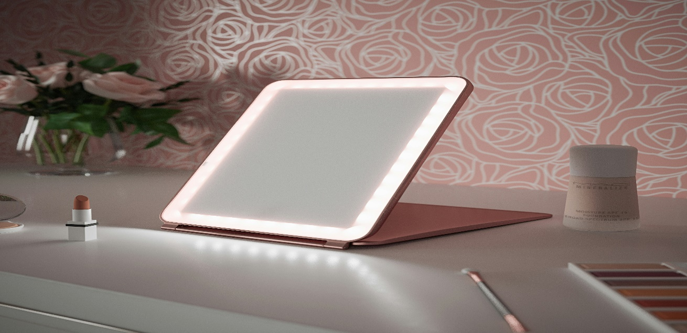
“SMART DRESSING MIRROR”
Dressing mirrors are an important part of a well-organized and stylish interior, offering both practicality and visual elegance. A dressing mirror is specially designed to provide a clear, full view, making daily routines like getting ready, outfit selection, and personal grooming more convenient and comfortable. Whether placed in a dressing area, bedroom corner, or attached to a wardrobe, a dressing mirror enhances the functionality of the space while adding a refined decorative touch. Available in full-length, wall-mounted, or framed designs, dressing mirrors can easily match different interior styles, from modern and minimal to classic and luxurious. They also help brighten the room by reflecting light, creating a sense of openness and neatness. High-quality dressing mirrors are made with premium, distortion-free glass to ensure accurate reflections and long-term durability. Overall, a dressing mirror is not just a useful everyday item but a stylish element that adds confidence, comfort, and sophistication to any dressing space.

